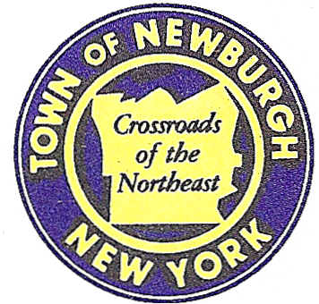

TOWN OF NEWBURGH
_______Crossroads of the Northeast __________________________
OLD TOWN HALL
308 GARDNERTOWN ROAD NEWBURGH, NEW YORK 12550

PLANNING BOARD
JOHN P. EWASUTYN, CHAIRMAN TELEPHONE 845-564-7804
FAX 845-564-7802
E-MAIL: planningboard@townofnewburgh.org

PLANNING BOARD AGENDA

JULY 17, 2014

**PLEASE NOTE: The Planning Board Meeting will start at 7:00 P.M. and all Applicants/Representatives
are to be present at that time. The Meeting will be held in the Meeting Room of Town Hall, located at
1496 Route 300, Newburgh NY.**

- Chadwick Lake/Crown (Verizon) (2014-13)  409 Quaker Street  Sec: 11, Block 1, Lot 143  Zone: AR  Rep: NB&C Engineering Services  1777 Sentry Parkway West  Dublin Hall, Suite 210  Blue Bell, PA 19422 | SITE PLAN  WIRELESS COMMUNICATION  PUBLIC HEARING
- Dixon Subdivision II (2014-15)  85 Forest Road  Sec: 3, Block 1, Lot 103.31  Zone: AR  Rep: Talcott Engineering  1 Gardnertown Road  Newburgh, NY 12550 | SUBDIVISION  INITIAL APPEARANCE
- Britain Plaza (2013-13)  169 Old Little Britain Road  Section 97, Block 3, Lots 1& 2  Zone: IB  Rep: Lanc & Tully, PC  P.O. Box 687  Goshen, NY 10924 | SITE PLAN
- Hampton Inn & Suites and Restaurant (2014-16)  Route 17K & Crossroads Court  Sec: 95, Block 1, Lot 45.12  Zone: IB  Rep: Maser Consulting  1607 Route 300, Suite 101  Newburgh, NY 12550 | SITE PLAN  INITIAL APPEARANCE
*WORK SESSION: Project Readiness Discussion scheduled for 5:30 p.m. in the Meeting Room
of Town Hall on Thursday, July 17, 2014*

PLANNING BOARD BUSINESS
WORK SESSION

JULY 17, 2014

Discussion:

